Fourth Week Deliverable: Group A-5

1. Working Dummy: <http://ceclnx01.cec.miamioh.edu/~wrightes/201project/index.html>
2. 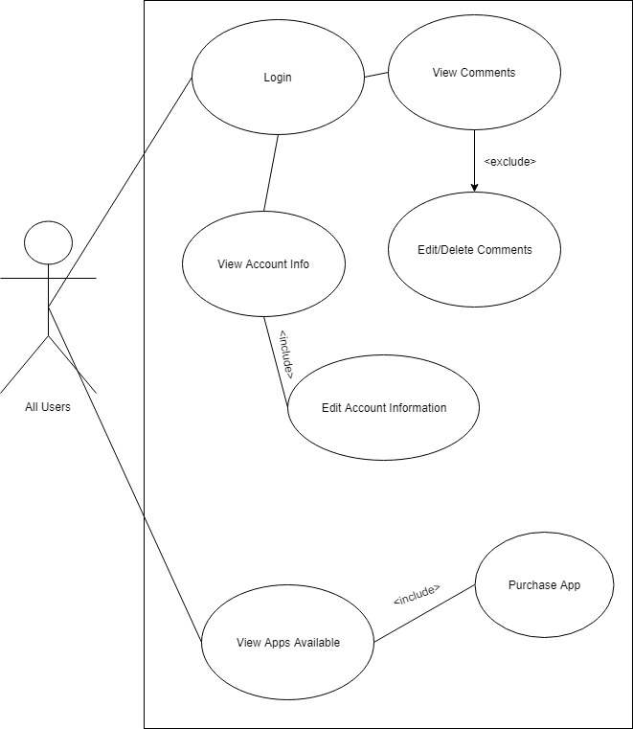

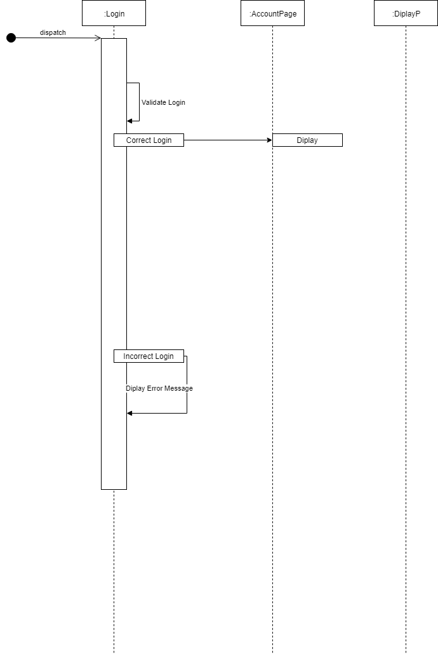

1. Iteration 2 Burn down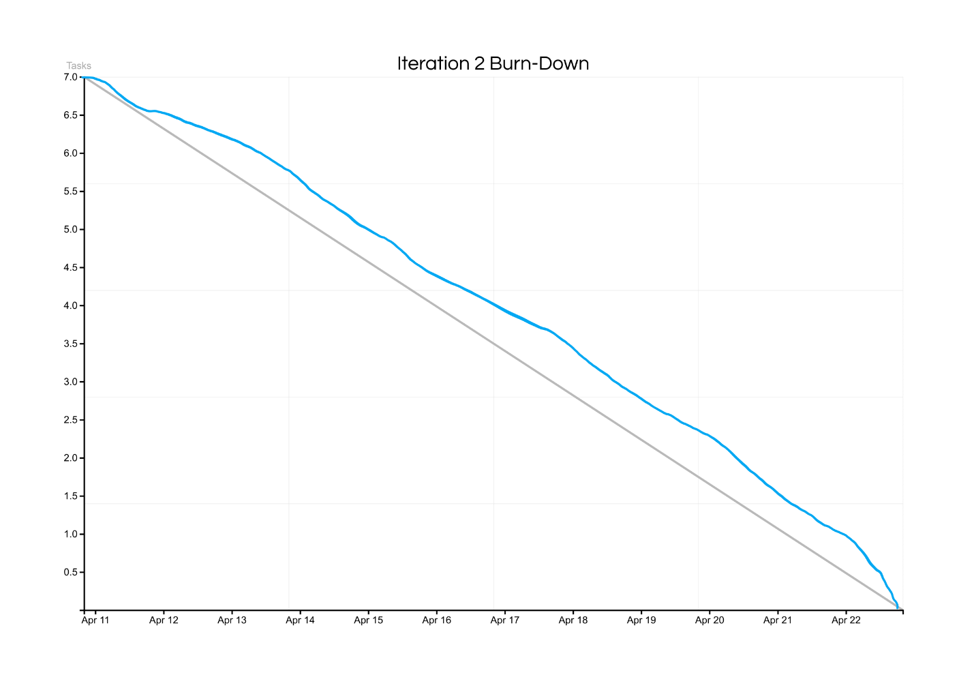
2. Iteration 2 Requirements
   1. A user shall be able to have access to a single page where they can track requests
      1. High
   2. A user shall be able to view the status of their requests
      1. High
   3. A user shall be able to edit the contents of their requests
      1. Medium
   4. A user shall be able to delete one or more of their requests
      1. Medium
   5. A user shall be able to submit requests on a single page
      1. High
   6. An administrator shall be able to approve requests
      1. Low
   7. An administrator will be able to deny requests
      1. Low
   8. An administrator can view all their respective requests on a single page
      1. Medium